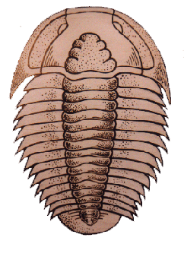
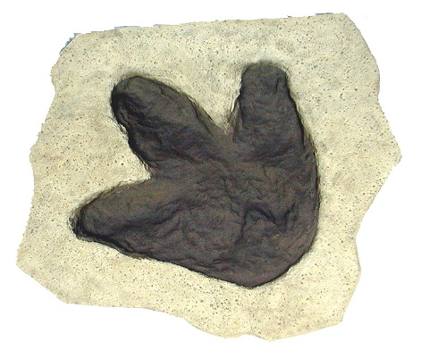
Lawrence University Science Lab Day
BRINGING FOSSILS TO LIFE
Saturday, May 9, 2015
1:00 - 4:30
for 5th to 8th grade students who love science

The Science Lab Day will take you on a paleontogolical adventure, decoding how we learn about past and present life from fossils. Join paleontological investigator Shane Cullian, microbiology specialist Will Tyler, and Lawrence University science majors in the lab as they explore how scientists work to understand the world.

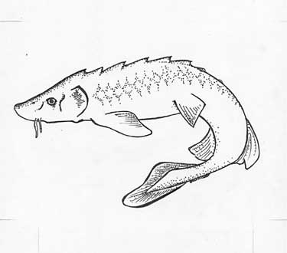
hands-on explorations in real labs

* investigate fossil footprints
* discover living fossils
* research early life forms still alive today

More information available from
www.lawrence.edu/dept/biology/department_programs/sciencecamp.shtml
Cindy Duckert, 920-202-4850 or email duckertc@lawrence.edu

Space is limited to 50 Registrations due by May 6

* * * * * * * * * * * * * * * * * * * * * * *
Lawrence University Science Lab Day: BRINGING FOSSILS TO LIFE
Saturday, May 9, 2015 1:00 - 4:30

Name_________________________________________________ Age _____

Address ____________________________________ Phone _________________

City, Zipcode _________________________________ Email ___________________________

Mail $10 payable to Lawrence Univ.& Registration form to:
Lawrence Science Lab Day Special note from parents or list a friend to be a lab partner:
Lawrence University
711 E. Boldt Way
Appleton, WI 54911
fax 920-832-6962

