

ALLERGIES

Symptoms

Allergy symptoms can affect your airways, sinuses and nasal passages, skin, and digestive system. Allergic reactions can range from mild to severe.

**Know your Triggers**

You may think that pollen is causing your suffering, but other substances may be involved as well. More than two-thirds of spring allergy sufferers actually have year-round symptoms.

PREVENTION

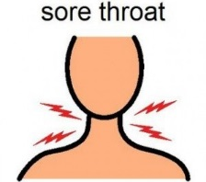

Sore Throat

Itch, Red Eyes

Rashes

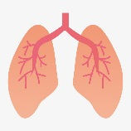

Wheezing

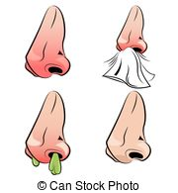

Sneezing, Itchy Nose

COMMON ALLERGENS

**Pollen -** Grasses, trees and weeds produce pollens that travel through the air and are inhaled. They cause seasonal allergy symptoms and can trigger asthma. Pollens from trees are higher in the spring, grasses in the summer and weeds in the fall. This may vary depending on weather conditions and where you live.

**Dust Mites -** Dust mites are tiny bugs that live in bedding, mattresses, upholstered furniture, and carpets. No matter how clean your house is, it's impossible to completely get rid of dust mites.

**Pets -** Allergic reactions to pets are caused by the animal's dander. Short-haired pets are not any less likely to cause a reaction than long-haired animals. If you have an allergy to animals, its best avoid exposure.

**Mold -** Molds are found in outdoor air and can enter your home any time you open a door or window. Any house can develop a mold problem with the right conditions. Molds like to grow on wallboard, wood, or fabrics, but they will grow any place. They thrive in closets, places where fresh food is stored, refrigerator drip trays, house plants, air conditioners, humidifiers, and garbage pails.

Prevention

* Avoid Known triggers
* Keep windows closed during pollen season, especially during the day.
* Take a shower, wash your hair, and change clothing after working or playing outdoors.
* Wash bedding weekly
* Clean regularly
* Monitor [pollen](http://acaai.org/allergies/types/pollen-allergy) and [mold](http://acaai.org/allergies/types/mold-allergy) counts.
* Start taking you medicine before allergies start

Treatment

* **Over the counter medications –** Medication can help manage your symptoms.
* Antihistamines come in pill, liquid or nasal spray form. They can relieve sneezing and itching in the nose and eyes. They also reduce a runny nose and, to a lesser extent, nasal stuffiness.
* Decongestants are available as pills, liquids, nasal sprays or drops. They help shrink the lining of the nasal passages and relieve nasal stuffiness. Use decongestant nose drops and sprays only on the short-term.
* Nasal sprays reduce inflammation in the nose and block allergic reactions. They are the most effective medicine type for allergic rhinitis because they can reduce all symptoms, including nasal congestion. Nasal corticosteroids have few side effects.
* **Be sure to check for drug interactions** between your personal prescriptions/over the counter medications with allergy medications using [**www.drugs.com**](http://www.drugs.com)
* **If your symptoms are intolerable** with OTC medication, you should consult with your doctor. Be prepared for your appointment. Keeping a diary helps to identify what causes or worsens your allergic symptoms, track your activities and what you eat, when symptoms occur and what seems to help. This may help you and your doctor identify triggers.