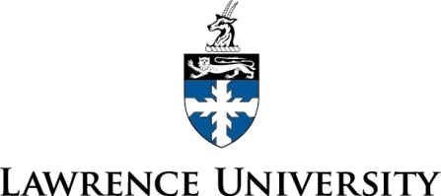

London, Amsterdam and Brussels

September 30 – October 09, 2014

September 30, 2014 Leave USA
Leave your home city today for your trans-Atlantic flight to London.

October 01, 2014 London D
11:05am Delta flight 56 arrives at London Heathrow airport from Detroit

Airport Transfer from Heathrow
We will be met in the arrival hall by our guide who will take us to our private coach.

Check-in at the:
Radisson Blu Edwardian Vanderbilt
68 Cromwell RD. London SW7 5BT

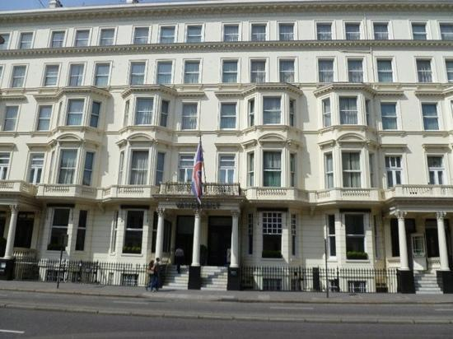

Remainder of the day at leisure

7:00pm Dinner at Scoff and Banter Restaurant

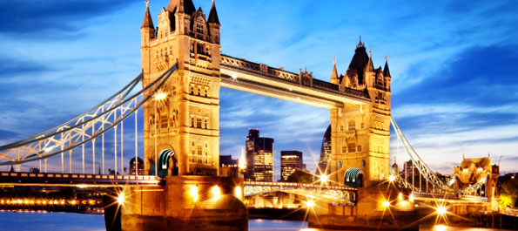
October 02, 2014 London B
In the morning we will enjoy breakfast at the hotel.

Day at Leisure:

Spend the day and evening exploring this wonderful city.

Overnight at: Radisson Blu Edwardian Vanderbilt

October 03, 2014 Amsterdam B D
In the morning we will enjoy breakfast at the hotel, and after check-out, our bus driver will transport us to Heathrow International Airport.

8: 30am Depart hotel with luggage
9:45am Check in for KLM flight 1010 to Amsterdam

KLM flight 1010 leaves London, Heathrow at 11:45am, arrives in Amsterdam 2:05pm

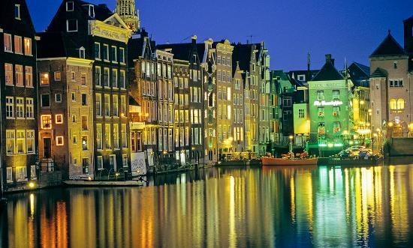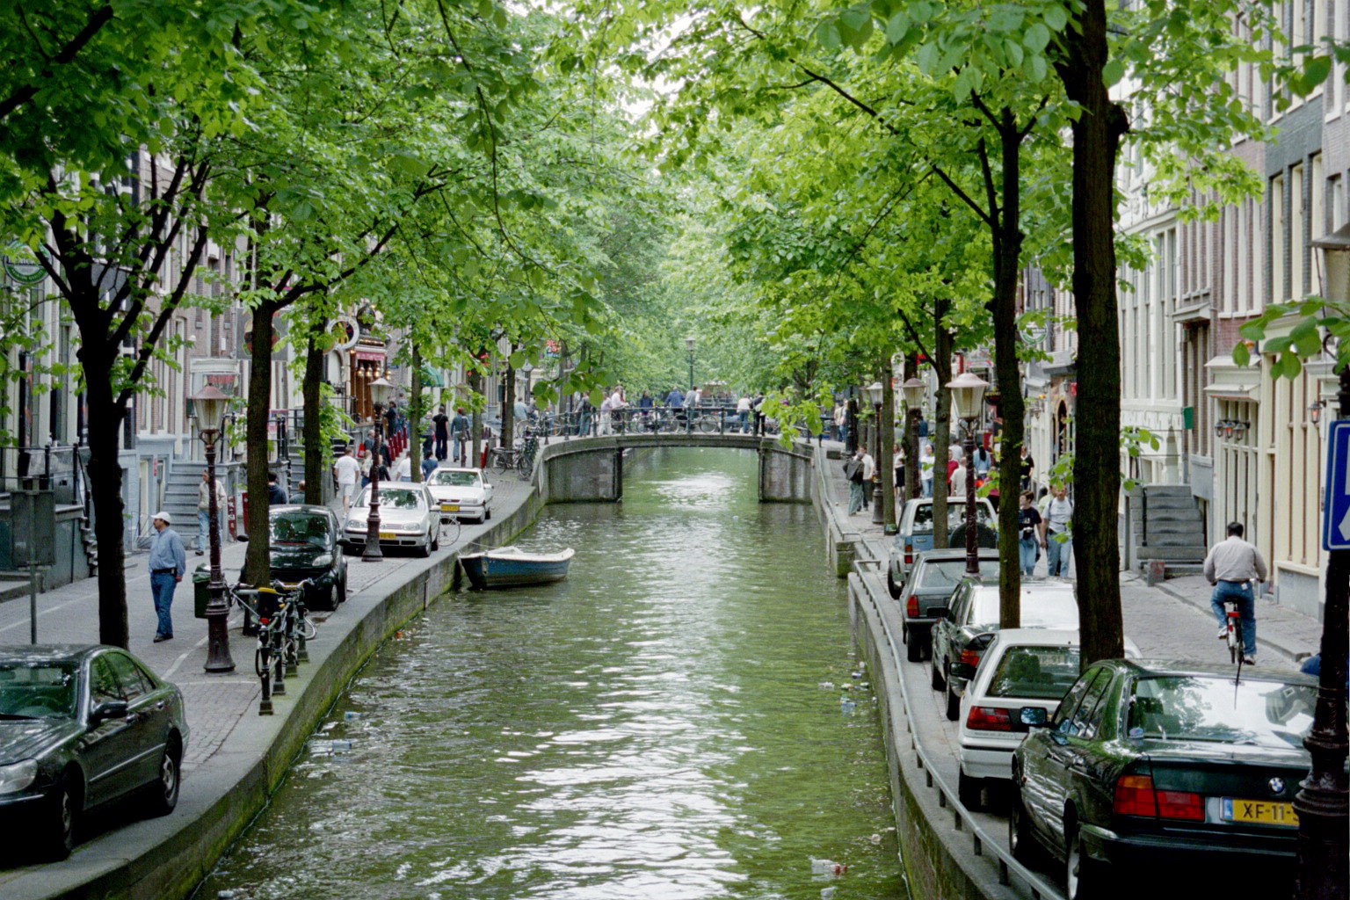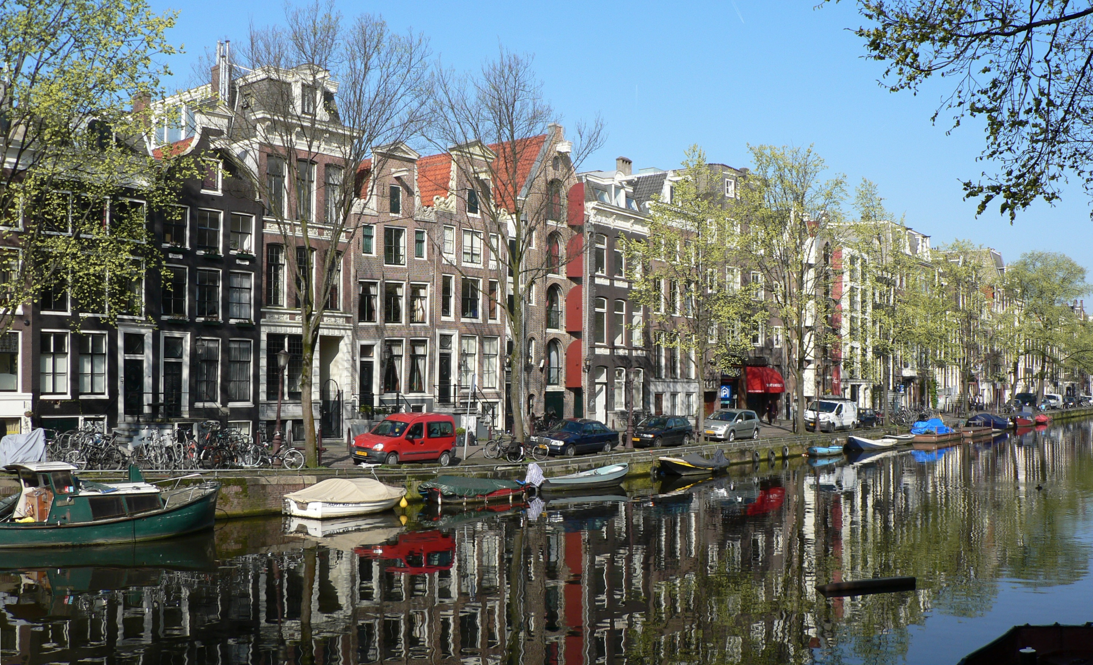

2:05pm Arrival at Schiphol Airport / KLM1010

Upon arrival at Schiphol Airport our guide will meet us at the gate and walk us to the private coach for a transfer to our hotel where we will enjoy the rest of the afternoon at leisure.

5:45pm Meet in hotel lobby for short walk to pier for dinner cruise.

6:00pm Dinner cruise, 3-course dinner with drinks

Canal cruise with salon boat “Soeverein”
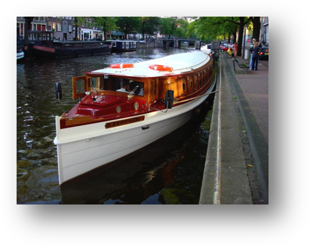

9:00pm Walk back to the hotel

Overnight at the Hotel Mercure
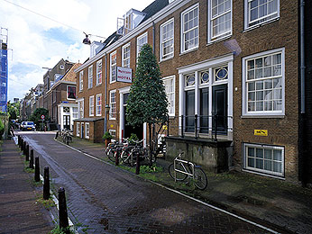

Hotel Mercure
Noorderstraat
Amsterdam, Netherlands

October 04, 2014 Sweeney Todd Show BD
In the morning we will enjoy breakfast at the hotel.

Day at Leisure:
We can spend our day exploring this fascinating city.

5:10pm Transfer by private coach to music hall Carré

The Royal Theatre Carré (Dutch: Koninklijk Theater Carré) is a Neo-Renaissance theatre in Amsterdam, located near the river Amstel. Upon arrival we will enjoy a welcome aperitif then we will be guided by our hostesses to Oscar’s restaurant to have an extended 3 course dinner, accompanied by drinks and homemade sweets. Around 7:45pm our hostesses will escort us to the theatre room where luxury seats are reserved for the whole group to experience Dale Duesing performing in Sweeney Todd. During a 30 minute break, we will enjoy drinks, cold appetizers and assorted table snacks. The show will end around 10.30pm and we will be transferred back to the hotel by our private coach.

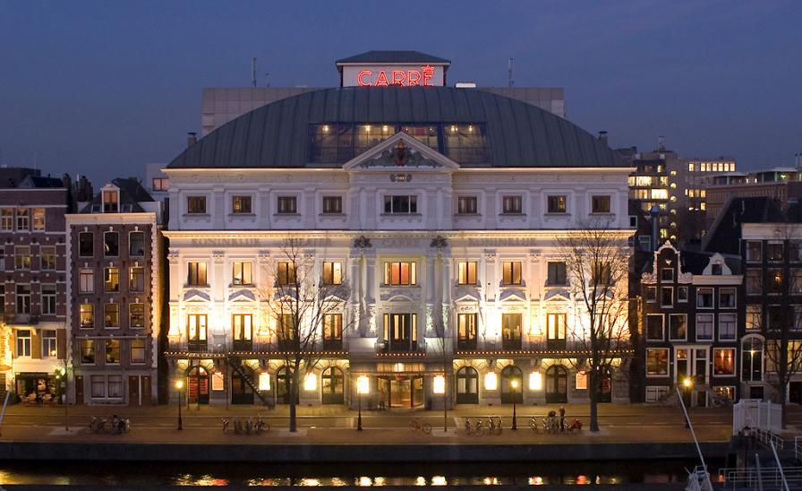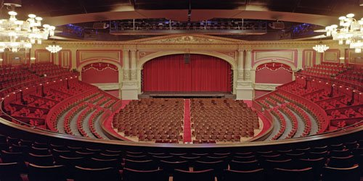

Overnight at the Hotel Mercure
October 05, 2014 Amsterdam BD
In the morning we will enjoy breakfast at the hotel.

Day at Leisure:
We will have more time to wander Amsterdam.

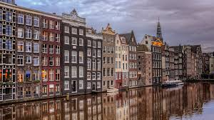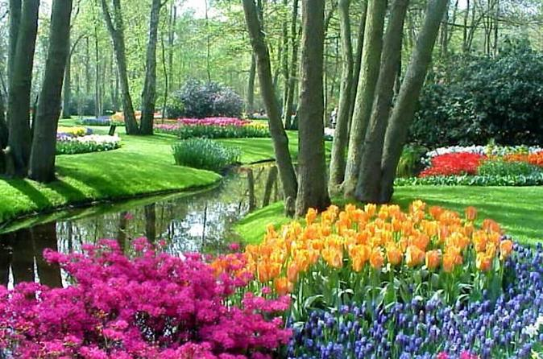

6:30pm Meet in hotel lobby to walk to Restaurant Sluizer for dinner with Dale and Marcel.

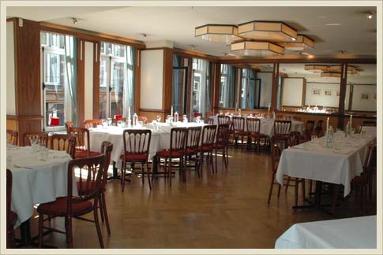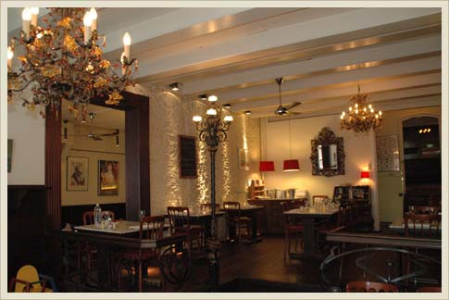

Overnight at Hotel Mercure

October 06, 2014 s-Hertogenbosch /Brussels BD
In the morning we will enjoy breakfast at the hotel.

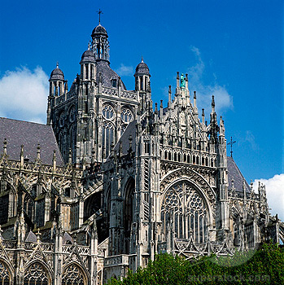

Our private coach will transfer us from Amsterdam to Hotel Royal Windsor Brussels. The coach will make a stop in s-Hertogenbosch for lunch and a small visit of this town. The city's official name is a contraction of the Dutch des Hertogen bosch—"the Duke's forest". 's-Hertogenbosch was founded as a fortified city and that heritage can still be seen today. Much of its historic heritage remains intact. 's-Hertogenbosch also has the oldest remaining brick house in the Netherlands, 'de Moriaan', which was built at the beginning of the 13th century. 's-Hertogenbosch is also home to Saint John's Cathedral, which dates from c. 1220 and is best known for its Brabantine Gothic design and the many sculptures of craftsmen that are sitting on almost every arc and rim along the outside of the cathedral. The painter Hieronymus Bosch (c. 1450–1516) remains probably the best known citizen of 's-Hertogenbosch. The city is also the location of the Bolwoningen complex, an array of fifty experimental spherical houses designed by Dries Kreijkamp. After this visit, the coach will transfer us to Hotel Royal Windsor in Brussels, where we will arrive around dinner time.

Dinner at Restaurant Aux Armes de Bruxelles

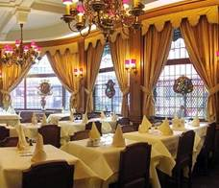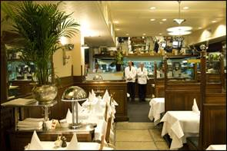

Overnight at Royal Windsor Brussels

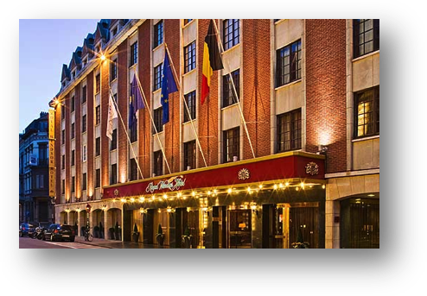

Royal Windsor Brussels
Rue Duquesnoy 5
1000 Brussels, Belgium

October 07, 2014 Bruges B L
In the morning we will enjoy breakfast at the hotel.

Our guide will meet us at our hotel and we will be transferred in a private coach to Bruges.

Bruges walking tour
The historic town of Bruges is a gorgeous Gothic city located near the Belgium coast. In the 11th century, Bruges was one of the world's largest cities. Today, it is a popular tourist destination that features famous landmarks, tourist attractions and some great museums and art galleries.

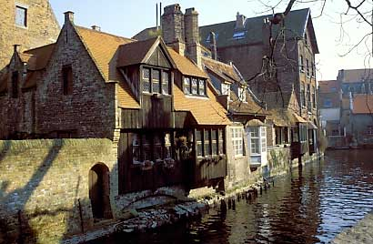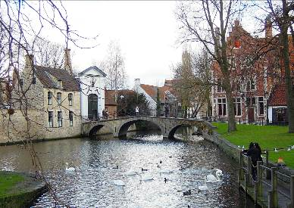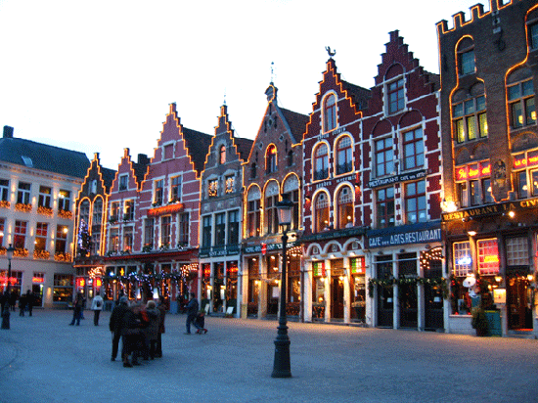
Boat Cruise included.

Dinner at leisure

Overnight at Hotel Royal Windsor

October 08, 2014 Mission /Waterloo BD
In the morning we will enjoy breakfast at the hotel.

Our private coach will bring us first to the US Mission for a visit. This is an exciting opportunity to spend time in a registered historic building and hear a briefing on relations between the United States and Europe conducted by a U.S. diplomat. After our visit we will continue the tour to Waterloo.

This historical tour of the infamous battlefield will take us on a journey through time to the day of Napoleon’s crushing defeat by the Duke of Wellington. Our interesting tour takes us to the "Butte de Lion" and its spectacular view of the perfectly preserved battlefield. We will see the Panorama, the Wellington museum and end the tour with delectable local pastries during a visit to a local historical farm.
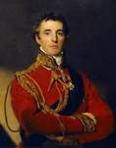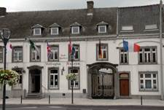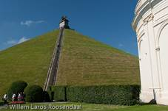
6:00pm Arrival at the hotel in Brussels

6:50pm Meet in hotel lobby for walk to the restaurant

Farewell Dinner at Restaurant Vert de Gris

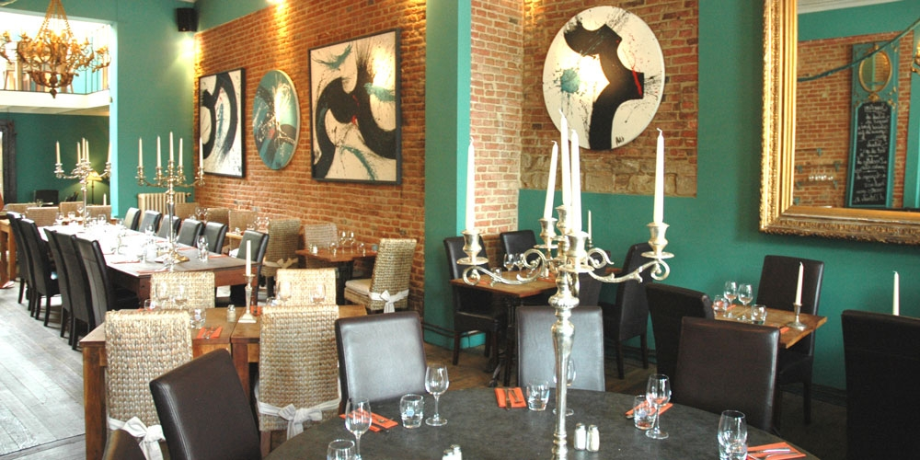

7:00pm 3-course dinner excluding drinks

Overnight at Hotel Royal Windsor

October 09, 2014 Flight Back Home B
Having enjoyed breakfast at the hotel and checked out before noon, our private driver will pick us up and transfer us to Brussels airport. Here we get to board our homeward flight.

TOUR DETAILS

Land Cost Per Person: $3700.00, based on twin occupancy. A limited number of single rooms are available at a supplemental charge of $900.00. This supplement pays for privacy, not better or larger accommodations. Please contact our office for availability.

Airfare is available on Delta Airlines from Appleton or Detroit for $1350.00 pp.

The trip cost is based on a minimum of 32 participants. Should fewer than 32 paying participants sign up, Lawrence University and TravelStore reserve the right to re-price the program or cancel the tour and provide a full refund.

A deposit of $1,200.00 per person is required at the time of booking. Final payment is due no later than July 28, 2014. Payment of deposit connotes your review and acceptance of these Terms and Conditions. We will acknowledge your reservation with an invoice, which will also serve as your confirmation.

Included Services:
- 8 nights hotel stay
- Meals as listed in the itinerary
- Deluxe motor coach for touring, transfers and excursions as listed
- Service of a professional driver and guide, and local guides
- All sightseeing with entrance fees
- Hotel Porterage for 1 piece of checked luggage per person
- Service charges and taxes
- Tips and gratuities for included services
- International airline tickets
- Internal flights within London and Amsterdam

Not Included:
- Passport and visa fees ( if applicable for non US passport holders)
- Communication costs, such as phone calls, emails, and faxes
- Any items of a personal nature
- Any items not included in inclusions
- insurance

Cancellation & Change Penalties: For cancellations made prior to July 28, 2014, a $1,200.00 per person cancellation fee applies. No refund can be paid for cancellations made on or after July 28, 2014. No refund will be given for services voluntarily not taken or for cancellations during the group itinerary. Airline tickets have separate changes and cancellation fees depending on fare paid and date of change or cancellation. TRAVEL INSURANCE IS STRONGLY RECOMMENDED.

Dietary & Health Considerations: This program will be moderately active and will include walking uphill, walking on uneven surfaces, and the handling of luggage. It is the responsibility of the tour participant to advise in advance of any health or dietary limitations that may affect the tour's successful operation or compromise the tour participant's enjoyment, including, but not limited to, getting on and off a motor coach, climbing stairs, or walking with any impediment. There is a no-smoking policy on the motor coach. No inoculations are required for travel to Europe at this time; however, you may wish to check with your doctor about any precautions you may need to take based on your health conditions.

Tour Cancellation & Alteration: TravelStore and Lawrence University reserve the right to cancel this trip if a minimum number of participants are not reached. In that eventuality any payments made to TravelStore for this tour will be refunded without penalty, and without further obligation on the part of TravelStore or Lawrence University.
TravelStore VIP and Lawrence University reserve the right to cancel the program if, due to circumstances beyond TravelStore's or Lawrence University control, the tour cannot be conducted substantially as outlined. TravelStore reserves the right to make minor alterations that do not significantly affect the content of the tour.

Conditions of Contract: Neither Travel Store Inc., Lawrence University, the Lawrence University Alumni Association nor any of their employees, officers, directors or affiliates, own or operate any entity which provides goods and services for this program, and act only as agents for the independent suppliers of travel conveyance, transport, accommodation or other services. All such persons or entities are independent contractors.
TravelStore and Lawrence University, the Lawrence University Alumni Association, their agents, servants and employees shall not be responsible for personal injury or property damage, loss or delay, or change of itinerary incurred by any person or tour participant arising out of the act or negligence of any direct or supplemental air carrier, hotel or other person rendering any of these services, or accommodations being offered in this tour; nor shall TravelStore, Lawrence University or the Lawrence University Alumni Association be responsible for any injuries, death, damages, loss or delay in any means of transportation or by reason of any event beyond the actual control of TravelStore, Lawrence University and/or the Lawrence University Alumni Association, or of any agent supplier or due to force majeure; nor with other actions, omissions, or conditions outside TravelStore’s, Lawrence University 's or the Lawrence University Alumni Association’s control including terrorist activities, social or labor unrest, mechanical or construction difficulties, diseases, local law, climatic conditions, abnormal conditions, or developments, or any other actions, omissions, or other conditions outside TravelStore’s, Lawrence University 's or the Lawrence University Alumni Association’s control. The right is reserved to decline or accept or to retain any person as a member of a trip, or to cancel a trip, due to circumstances beyond the control of TravelStore, Lawrence University or the Lawrence University Alumni Association.
Dates, program details and tour costs, although given in good faith and based on tariffs, exchange rates and other information current at time of printing, are subject to change at or before the time of departure. While no revisions are anticipated, the right is reserved to substitute hotels of similar category or change schedules or other inclusions without prior notice should circumstances so demand or be made necessary, with the mutual understanding that any additional expenses will be paid by the individual passenger. In the event of a change in the itinerary necessitated by factors or conditions beyond the actual control of TravelStore, Lawrence University or the Lawrence University Alumni Association, no refund can be made nor will credit be allowed, provided that in the event of such change in itinerary, TravelStore shall attempt to provide accommodations and services of comparable quality and standards as set forth in the itinerary.
Any such change shall not modify the cancellation provisions in the brochure. No credit will be allowed or refund given for any services should any such services not be utilized by the tour members. Availability of refunds for air transportation depends on the type of air tickets purchased, and the point at which transportation is not used.
Participation on this program is subject to acceptance that the participant, his/her heirs, executors, agents, representatives, insurers or attorneys release and discharge TravelStore, Lawrence University and the Lawrence University Alumni Association, its officers, trustees, faculty, employees and representatives from any and all claims which may arise from any cause whatsoever, regardless of the source, and from responsibility for any accident, illness or injury or any other consequences arising or resulting directly or indirectly from participation in this program.

TravelStore CST# 2002736-10.

INSURANCE: Travel insurance for travel accident, loss/damage/delay of baggage, flight insurance and trip cancellation insurance is strongly recommended. Applications will be sent on request.

OPERATORS: This program is operated by Travelstore of Brentwood, California, ITB Holland and In Any Event.

FOR FURTHER INFORMATION, PLEASE CONTACT:
Nada Vostmyer
Travelstore
11601 Wilshire Blvd
Suite 300
Los Angeles CA 90025

310-689-5420 –Direct phone/fax
Nada.v@travelstore.com

Please print and mail the Reservation form* to:
TravelStore
Attn: Nada Vostmyer
11601 Wilshire Blvd, Suite 300
Los Angeles, CA 90025

*The Reservation form is found on the International Travel for Alumni webpage underneath the Itinerary button.

