The eurozone after Strauss-Kahn
By Martin Wolf Published: May 17 2011 21:33 | Last updated: May 17 2011 21:33
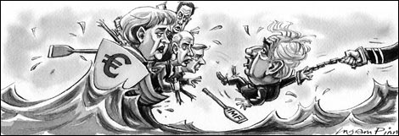
The sight of Dominique Strauss-Kahn, managing director of the International Monetary Fund and prospective candidate for the French presidency, doing the “perp walk” was stupefying. If the charges are true, this capable man is a lunatic. But, unless the case collapses, the event will cast a long shadow.
Mr Strauss-Kahn turned out to be the right man in the right job at the right time. Initially, I had my doubts about the appointment of yet another Frenchman and a politician, at that, to run such a central international institution. I was wrong. Mr Strauss-Kahn proved to be a bold decision-maker, an effective politician and a competent economist. This combination is very rare. None of the candidates under discussion is likely to do the job as well as he did during the worst of the global and then eurozone financial crises.
Of course, it was widely expected that Mr Strauss-Kahn would shortly depart from the IMF, to run for the French presidency. But if he had won, he might have transformed the eurozone’s ability to manage its current internal crisis. Certainly, he would have brought to this task abilities the current French president, Nicolas Sarkozy, lacks: above all, intellectual weight and so credibility with policymakers in Germany, Europe’s premier power.
Mr Strauss-Kahn was among the very few senior European policymakers to whom the German leadership, particularly Angela Merkel, the chancellor, paid attention. At crucial moments, he was able to bring Europeans together. Indeed, he even seemed able to bring a divided German government together. I cannot imagine who could replace him. When there exist so many divisions within Europe and the decisions ahead are so complex and fraught, his absence will be keenly felt.
Inevitably, there is already much discussion of who might replace Mr Strauss-Kahn at the IMF. It is easy to think of able technocrats across the world. It is also possible to think of politically effective personalities. Nobody combines these twin facets as well as he did. The issue of nationality will also arise. Europeans will, I suspect, insist that it should be another European, possibly Christine Lagarde, the current French finance minister. The emerging countries will put forward their own candidates. But given the central role the IMF now plays within the eurozone, as source of finance and, still more, of expertise, it is hard to imagine the Europeans would concede. I suspect that the US would back them, in which case they will have the votes. Certainly, no non-European could play the role Mr Strauss-Kahn did in the eurozone.
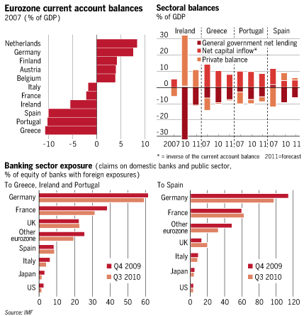Mr Strauss-Kahn’s downfall happens to come at an important moment. As I argued last week, the Greek programme has not worked as planned. This is not surprising: it never seemed likely that it would do so. There is a good chance that the same will ultimately prove true of Portugal’s €78bn programme. Ireland is definitely not back to health. In a world of multiple equilibria, even Spain is far from sure to manage the adjustments ahead. Moreover, as the IMF’s new survey of Europe argues, the eurozone’s highly leveraged banking system remains vulnerable.
The underlying economics of the crises are clear. During the boom years, a number of countries were able to borrow more and on more favourable terms than ever before. They, then, ran huge current account deficits. The latter turned out to be the leading indicator of future crises, not fiscal deficits, as Germany’s mistaken conventional wisdom would have it. The domestic counterparts of these external deficits could be huge fiscal deficits (as in Greece), huge private financial deficits (as in Ireland and Spain) or a combination of the two (as in Portugal). (See charts above). Indeed, we now know that the distinction between private deficits and debt and public deficits and debt is far less absolute than the fiscal priesthood understands: private debt becomes public debt and private deficits become public deficits very swiftly. In a crisis, huge external deficits also result in “sudden stops” in the inflow of external finance and so the need for official support, to finance the ongoing fiscal and current account deficits and capital flight.
A country with a debt-encumbered private sector that is also seeking to reduce a huge structural fiscal deficit has to generate an offsetting improvement in its current account. This is a matter of logic. Consider Portugal. According to the IMF, it had a current account deficit of 10 per cent of gross domestic product last year, a fiscal deficit of 7 per cent of GDP and so an implied private sector deficit of 3 per cent of GDP (see chart). If the fiscal deficit is to be improved without pushing the private sector into greater deficit, the current account must improve sharply. But this entails a surge in competitiveness. The competitiveness challenge confronting these countries is much greater than that facing Germany in the late 1990s.
Quite apart from financing adjustment, somebody must also bear the losses on past bad lending and borrowing. In its wisdom, the eurozone has decided that the losses of private sector creditors should be socialised and the ultimate burden fall on the taxpayers of deficit countries. The latter will then suffer first a slump and then years of fiscal austerity. The justification for all this is the view, particularly strongly held in the European Central Bank, that the eurozone cannot cope with any defaults, be they on lending to banks or on lending to governments. Again, the distinction between private and public debt dissolves.
Yet the problem with the strategy of imposing the burden on taxpayers in borrowing countries is that it is unlikely to work. As an ever greater proportion of the financing ends up with official sources, the latter are likely to end up bearing politically explosive costs when debts are written off. Some “private sector involvement” – or at least extensions in maturity – will be required as well. So, too, must there be write-downs of loans to bankrupt banks and subsequent recapitalisation of damaged financial institutions.
Such a crisis is hard to resolve. How should adjustment be financed? Who should bear the losses? How should panic be minimised? The challenges are enormous. Today’s strategy requires ever greater official finance for ever longer periods. Will it be forthcoming? If not, somebody needs to think afresh. With Mr Strauss-Kahn gone, I wonder who will now be able to give the lead.
martin.wolf@ft.com

